**Rowantree Primary School Relationships Policy**

PURPOSE OF THE POLICY

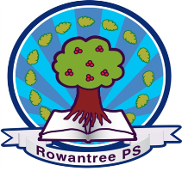

In Rowantree Primary we are committed to providing a consistent and calm approach to promoting positive behaviour within a climate of mutual respect and trust.

Our Relationships Policy is guided by the principles set forth in the United Nations Convention on the Rights of the Child (UNCRC). We are proud of our welcoming and inclusive Rowantree family where our children can enjoy a safe, structured, and happy environment to grow and learn in.

We want to provide the best possible chance of successful opportunities for our young people to flourish and to feel valued in all that they do.

Our Vision Values and Aims are interlinked with the principles and articles of the UNCRC:

* Wellbeing, positive relationships and an inclusive ethos and culture are the foundation for learning (**Article 2, 3, 6, 12, 2, 24, 30 and 31**).
* Children have a right to education (**Article 28**).
* Children have the right to get the support they need to benefit fully from their education and fulfil their potential (**Article 29**).

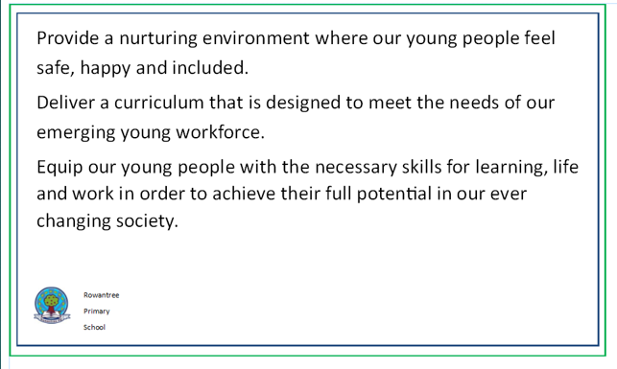

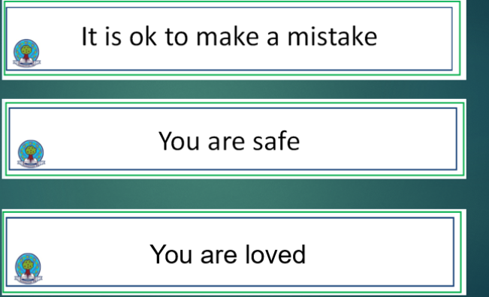

**Objectives**

**Respect for Children’s Rights:** Ensure all restorative practices respect the rights of children as enshrined in the UNCRC.

**Positive Learning Environment**: Foster a positive, supportive, and secure atmosphere conducive to learning and personal growth.

**Fairness and Equity** Implement fair and equitable behaviour management strategies that consider the diverse needs of students.

**Restorative Practices**: Encourage restorative approaches that promote understanding, accountability, and reconciliation.

**Key Principles**

**Non-Discrimination Article 2** Every child has the right to be treated with respect and fairness, regardless of their background, abilities, or personal circumstances.

**Best interests of the Child Article 3:** The best interests of the child are the primary consideration in all decisions affecting them.

**Right to Life Survival and Development 4:** Children have the right to a safe environment that supports their physical, mental, and emotional development.

**Respect for the Views of the child Article 12** Children have the right to express their views freely in all matters affecting them and to have those views given due weight according to their age and maturity.

**Behaviour Expectation (Safe, Ready, Respect)**

**Respect and Dignity**: All members of the school community are expected to treat each other with respect and dignity.

**Safety and Wellbeing:** Students should contribute to a safe and supportive environment by adhering to school rules and being mindful of the well-being of others.

**Responsibility and Accountability:** Our young people are encouraged to take responsibility for their choices and understand the impact they have on others.

**Strategies to support:**

**Preventative Measure:**

Clear, consistent expectations.

Provide engaging and inclusive curriculum and activities.

Foster strong child – school staff relationships based on mutual respect and trust.

**Positive Reinforcement ( see Appendix 1)**

Recognise and reward positive behaviour.

Nobody walks past – friendly greetings with all children.

Use praise and encouragement to reinforce good choices.

**Restorative practices:**

Use of scripting where appropriate

Restorative conversations and mediation to address conflicts.

Encourage our young people to reflect on their choices, understand the impact, and make amends.

**Supportive Interventions:**

Provide additional support for students with behavioural difficulties.

Engage with parents, guardians, and external agencies when necessary to support the young person’s well-being.

**Sanctions: (see Appendix 2)**

Apply sanctions fairly and proportionately, ensuring they are in line with the child's rights and best interests.

Avoid punitive measures that do not contribute to the child's understanding or improvement in behaviour.

**Implementation**

**Career- long Professional Learning**: Staff will receive ongoing training on children's rights, positive behaviour management, and restorative practices. Use of Good Practice Checklist is essential to the learning environment.

**Pupil Voice:** Our Young People will be involved in the development and review of behaviour policies to ensure their views are considered.

**Monitoring and Evaluation:** Regular monitoring and evaluation of behaviour management practices will be conducted to ensure they align with the principles of the UNCRC.

This Behaviour Management Policy underscores our commitment to upholding the rights of children as outlined in the UNCRC. By fostering a respectful, fair, and supportive environment, we aim to support the holistic development and well-being of every student.

Policy Review: This policy will be reviewed annually to ensure its effectiveness and alignment with current best practices and legal requirements.

**Appendix 1**

|  |
| --- |
| Positive Reinforcement Strategies |
| Positive photo on Seesaw to home for children who go ‘over and above’ any member of staff can give this recognition. This should be a minimum of 3 per class per week |
| Photo on Twitter for Over and Above |
| Teachers and parents/ carers can share children’s wider successes through Seesaw. |
| Nobody walks past, daily greetings |
| Class Rewards / Motivational practice |
| Achievement Awards certificates are given out weekly. |
| Social Awards – picked by Support Staff making observations of following expectations |
| Star Award Winner Breakfast Every Fri morning |
| House Points Awarded daily for following expectations |
| Recognition Boards in classrooms |
| End of Year awards |

|  |  |
| --- | --- |
| **Behaviour type** | **Logical Consequences** |
| Not taking care of school property | Removal of property for safety (if appropriate)  Help repair resources, if possible  Tidy space  CT to Inform parents by phone call, if necessary  Restorative conversation |
| Refusal to complete learning tasks  Wasting learning time  Rushing through learning jobs | Complete at home (at CT/parent discretion)  Remind pupil of best version  ASN scripting  Refer to ABLe plan if appropriate. |
| Disrespectful behaviour | Reminder of expectations  Time out in class safe space  Restorative conversation linked to VVA.  Use scripting.  Time out with support staff  Return to class when regulated.  Inform SLT  Report to parents/carer. |
| Unsafe choices in moment around the school | Fix area with support – where appropriate  Scripting school expectations when necessary- safe, ready, respectful  Alert support staff – this could lead to time out in another area  Inform SLT  Report to parents/carers  SLT to contact Parent/Carer |
| Unsafe behaviour | Removed from room carefully and safely for child and peer safety  Given chance to calm down in safe space  Care plans and risk assessments to be accurate and up to date for each child.  Consistency of VI to be recorded asap  Refer to logical consequences (age appropriate) |
| Sexualised behaviour | Report as appropriate.  CFC SLT to follow Child Protection flowchart. |

**Appendix 2**