

Rowantree Primary School Child Protection Guidelines

Revised April 2025

“… school staff… play a crucial role in the support and protection of children as well as the

development of their wellbeing. …Teachers are likely to have the greatest level of day-to-day contact with children and so are well placed to observe physical and psychological changes in a child that could indicate abuse and to contribute to the assessment of vulnerable children”

# National Guidance for Child Protection in Scotland (2014) Authority Guidelines:

Rowantree Primary follows the guidelines laid out by the authority: (<http://www.dundeeprotects.co.uk/>)



dcc cp

guidelines.pdf

[](http://www.dundeeprotects.co.uk/)

# Specific to Rowantree Primary School Child Protection Officers:

* Mrs Ross
* Mrs Cook
* Miss Elder
* Mrs Kay
* HT as Named Person requires overview of all CP concerns

# Cause for Concern

* Complete cause for concern form (appendix 1)
* Email it to a member of the Senior Leadership Team
* SLT will then record this onto pastoral notes Any relevant information will be shared

# Child Protection Red Alert

* Card in class
* Card on ID badge
* Send to SLT
* Do not discuss any CP in open areas or in front of pupils
* Do not share the issue/concern with anyone other than the CPO or HT

Serious Red Alerts will be recorded by SLT on Child Protection Concern form (appendix 2)

# Child Protection Posters

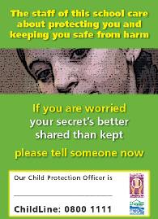All classes must display a CP poster



cp posters.pdf

# Badge Card:

Every member of staff should have a very brief ‘do’s and don’ts card with them at all times

**General Points**

* maintain eye contact
* let child know what you will do
* assume it is difficult for child to talk about this
* try to find out what child is most afraid of
* make notes as soon as possible

**To finish**

* reassure the child

-make child aware you may have to share information

* let child know exactly what you are going to do and as far as possible what will happen next
* praise child for being brave enough to come forward
* try to finish on as positive note as possible

**Child Protection - dealing with a disclosure Helpful things to say**

* you were right to tell and it's okay
* I am sorry this has happened to you
* it is not your fault
* I care and I will help
* you were brave to tell me

**Try to avoid saying**

* are you sure
* why didn't you tell anyone before
* I can't believe it
* statements like - I'm shocked or don't tell anyone else
* anything you can't follow through - eg false promises

# Safeguarding Leaflet:

All classes should have the following leaflet available in class

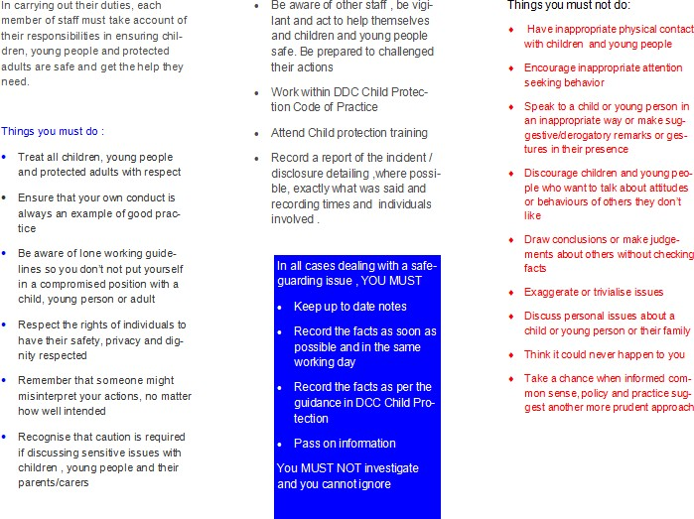

# Looked After and Accommodated Pupils:

It is incumbent upon us all to ensure we protect the most vulnerable pupils and those most likely to miss out. The Senior Leadership Team have a list of pupils who LAAC, on the CP register, Young Carers and any other vulnerable children.

This group of children have an extra layer of scrutiny including: weekly attendance review, more regular attainment and progress updates, regular review of targeted interventions to support .

The SLT have a discrete CEYP protocol to ensure accuracy of records. (appendix 3)

# (appendix 1)

Rowantree Primary School Cause for Concern

Please complete and return to member of SLT.

|  |  |
| --- | --- |
| Name of  Child |  |
| Class |  |
| Summary of Concern: | |
|  | |
| Signed: |  |

# (appendix 2)

***Dundee City Council – Children and Families Service***

**Child Protection Record of Concern – Education**

|  |  |  |  |  |  |
| --- | --- | --- | --- | --- | --- |
| **1. School** | |  | | | |
| **2. Child Protection Officer** | |  | | | |
| **3. Child / Young Person** | |  | | | |
| **4. Address** | |  | | | |
|  | | | |
| **5. Date of Birth** | |  | | **6. Gender** |  |
| **7. Household Composition (if known)** | | | | | |
| *Name* | | | *Relationship to Child* | | |
|  | | |  | | |
|  | | |  | | |
|  | | |  | | |
|  | | |  | | |
| **8. Detail of Concern** | | | | | |
| **Date** |  | | | | |
| **Nature of Concern** |  | | | | |
| **Concerns based on….** |  | | | | |
| **Reported by** |  | | | | |
| **9. Action taken by Child Protection Officer** | | | | | |
| *Date* | *Action* | | | | |
|  |  | | | | |

|  |  |  |  |  |  |  |  |  |  |  |
| --- | --- | --- | --- | --- | --- | --- | --- | --- | --- | --- |
|  | |  | | | | | | | | |
|  | |  | | | | | | | | |
|  | |  | | | | | | | | |
| **10. Concern shared with?** | | |  | | | | | | | |
| **11. Record** | CP  File? | |  | Pastoral Note? |  | | Mosaic Casenote? |  | Other |  |
| **12. Team Around the Child Meeting arranged?** | | | | | |  | | | | |
| **13. Signature of Child Protection Officer** | | | | | |  | | | | |
| **14. Countersignature of HT / DHT** | | | | | |  | | | | |

# (appendix 3)

CEYP Protocol

Head Teacher Informed

Head Techer informs SLT

SLT to update SEEMIS and add to pastoral notes

SLT to inform relevant staff

HT to update confidential list

Confidential list checked termly (attainment and attendance)