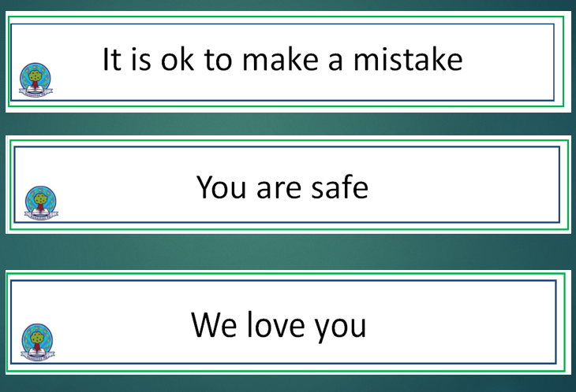
School Context April 24

Cycle of Improvement

Vision

Provide a nurturing environment where our young people feel safe, happy and included.

Deliver a curriculum that is designed to meet the needs of our emerging young workforce.

Equip our young people with the necessary skills for learning, life and work in order to achieve their full potential in our everchanging society.

Based on Summary Self-evaluation, School Improvement Report,
Annual Audit and feedback from Key Partners

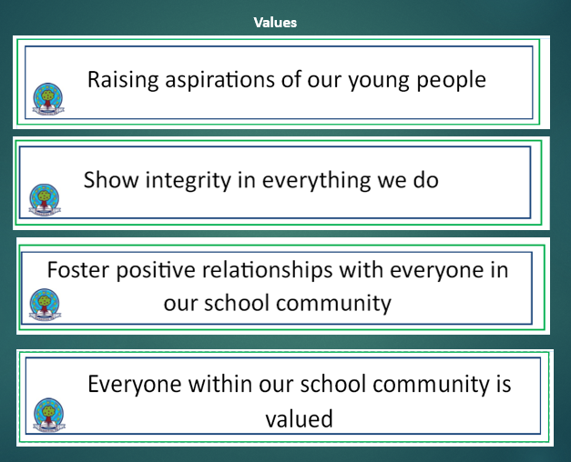
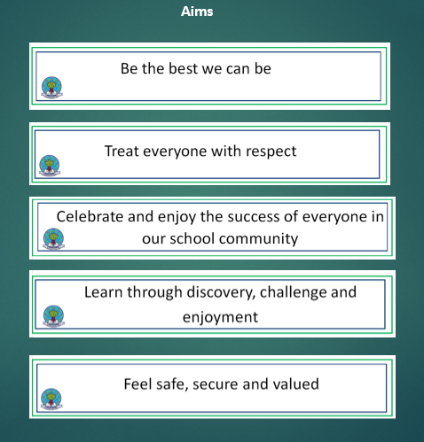

Presence
Participation
Progress


Presence
Participation
Progress
Progress
EDLM focus is attendance and Tools for Writing.
 | SCHOOL VERSION  SIP Priority 1  Specific area for improvement  PEF Equity Gap (if relevant) |  | Upskilling staff with numeracy pedagogy  Raise attainment in numeracy by knowing gaps and ensuring intervention address them.
 | NIF PRIORITY  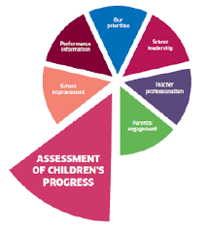  NIF Priority  Improvement in attainment in numeracy |  |  |  | EDLM PRIORITY    Progress  EDLM Priority  Progress |  | PEF (where applicable)  Intervention for equity & cost  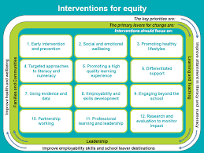  Resources  PEF can support the purchase of resources required to replenish and resources required for STEM activity,  Funding will be sought also. |  | HGIOS QI  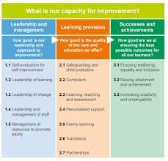  2.3  HGIOS QI  2.3 Learning, Teaching and Assessment
 | Action |  |  |  | Outcomes and Measurement Including use of HGIOS Challenge questions |  | Responsibility | Timescale |  | Progress
 | Engage with pedagogy team to explore differentiated teaching approaches considering assessment data.  Teachers to collaborate and plan lessons together, sharing best practices and resources.  Robust use of baseline assessment which must be analysed and lessons tailored to meet the diverse needs of students, providing additional support or challenges as needed.  Focus on teaching for conceptual understanding, using manipulatives and visual aids to illustrate abstract concepts.  Integrate problem-solving and critical thinking activities into the curriculum to help students apply mathematical concepts to real-world situations.  STEM Integration: Incorporate elements of science, technology, engineering, and mathematics (STEM) into math lessons to show the interconnectedness of these subjects.  Use a variety of assessment methods, including quizzes, projects, and oral presentations, to gauge children’s understanding. |  |  |  | Class teachers to create an attainment strategy plan for improvement for individuals or groups of children.  Teachers become more confident and skilled in using diverse instructional strategies, leading to more effective math teaching.  Increased pupil interest and participation in maths due to engaging and interactive lessons leading to improved attitudes to learning.  Students develop a solid understanding of mathematical concepts, enabling them to apply these concepts in various contexts.  A classroom culture that encourages curiosity, persistence, and a willingness to take risks in learning.  Improved pupil performance in numeracy attainment. |  | All teaching staff  Numeracy Working Group  SLT
SCHOOL VERSION  SIP Priority 2  Specific area for improvement  PEF Equity Gap (if relevant) |  | …Digital Schools Award Health & Wellbeing  …Digital Literacy – upskilling staff, ensuring progress and wellbeing of children
NIF PRIORITY  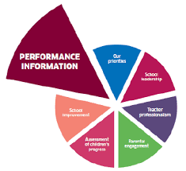  NIF Priority  Performance Information |  |  |  | EDLM PRIORITY  P,P,P  EDLM Priority  Presence,participation, progress |  | PEF (where applicable)  Intervention for equity & cost  N/A  PEF  N/A |  | HGIOS QI  1.3 | 3.2  HGIOS QI  2.3 Learning, Teaching and Assessment
Continue to integrate digital literacy into the curriculum to teach students about safe online behaviours, data privacy, and cybersecurity.  Continue to integrate digital literacy into the curriculum to teach students about safe online behaviours, data privacy, and cybersecurity.  the curriculum to teach our young  Continue to integrate digital literacy into the curriculum to teach students about safe online behaviours, data privacy, and cybersecurity.  Train students to be digital wellbeing ambassadors who can support their peers and promote positive digital behaviours.  Conduct regular workshops for children, teachers, and parents on topics like cyberbullying, screen time management, and digital footprints. |  |  |  | Identify strengths in the staff team and assign leadership roles  Students gain a better understanding of safe online behaviours, cybersecurity, and the importance of protecting their digital footprint.  A decrease in cyberbullying cases due to increased awareness and proactive measures taken by the school community.  More informed and engaged parents who actively participate in promoting healthy digital habits at home.  Children develop healthier relationships with technology, leading to a balanced use of screen time and improved overall wellbeing.  Children feel more empowered and responsible for their digital actions, fostering a positive digital culture in the school. |  | Depute Head Teacher to oversee.  Digital H & Wb Working Group |  | This box should be used to note progress throughout the session
SCHOOL VERSION  SIP Priority 3  Specific area for improvement: |  | Whole School Approach to food & health  Research tells us that poor diet and sleep routine impact overall health – our attendance is low and parents tell us this is due to ill health.
NIF PRIORITY  Whole School Approach to Food & Health |  |  |  | EDLM PRIORITY  P,P ,Progress  EDLM Priority  Presence, Participation & Progress |  | PEF (where applicable)  Intervention for equity & cost  N/A  PEF |  | HGIOS QI  3.1  HGIOS 3.1 Ensuring wellbeing, equality & inclusion
Action |  |  |  | Outcomes and Measurement Including use of HGIOS Challenge questions |  | Responsibility | Timescale |  | Progress
Conduct interactive workshops for children, teachers, and parents on the importance of balanced diets.  Integrate nutrition education into the curriculum through subjects like science and health education.  Work with dietitians, nutritionists, and other health professionals to provide expertise and support.  Partner with local businesses and organisations to support healthy eating initiatives  Implement policies that limit the availability of sugary drinks and junk food on school premises.  Implement educational sessions for children, parents, and teachers about the importance of sleep and its impact on health and academic performance.  Conduct workshops to teach practical tips on maintaining a healthy sleep routine, such as setting a regular bedtime, reducing screen time before bed, and creating a conducive sleep environment. |  |  |  | Students gain a better understanding of what constitutes a healthy diet and why it is important.  Reduced intake of sugary drinks and junk food.  Better nutrition contributes to improved concentration, energy levels, and overall academic performance.  Increased involvement of parents and the community in promoting healthy lifestyles.  Children develop lifelong healthy eating habits  A school culture that prioritizes health and well-being.  Improved sleep patterns and overall health leading to an increase in attendance. |  | Carl Skelton – Lead  Working Group H&Wb  All staff
ELC VERSION  NIP Priority 1  Specific area for improvement |  | Promoting and Enhancing a Child-Led Environment including Documenting Child-Led Learning
NIF PRIORITY  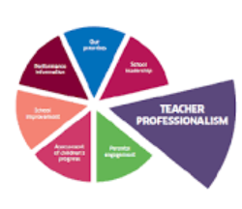  NIF Priority  Please select the appropriate NIF Driver (visuals included at the bottom of this document). There may be more than one NIF Priority identified |  |  |  | EDLM PRIORITY  Progress  Progress |  | Care Inspectorate Quality Framework QIs  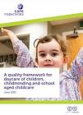  1.3 Play and Learning ·  2.1 Quality of the Setting for Care, Play and Learning ·  2.2 Children Experience High Quality Facilities |  | HGIOELC QI  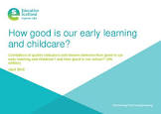  …  1.2.1.3,1.5,2.2  1.2 Leadership of Learning 1.3 Leadership of Change 1.5 Management ofResources to Promote Equity 2.2 Curriculum (Pedagogy  and Play)  · 2.3 Learning Teaching and
Action |  |  |  | Outcomes and Measurement Including use of HGIOELC Challenge questions |  | Responsibility | Timescale |  | Progress
Promoting and Enhancing a Child-Led Environment including Documenting Child-Led Learning |  |  |  | To develop practitioners understanding of child-led learning through providing ongoing training, team meetings and feedback. To develop deeper understanding of the planning cycle, supporting children to become co-facilitators in their learning. Monitoring and moderating spaces to ensure a consistently engaging and stimulating environment. |  | Michele Kay SEYP  Katie Elder EYCM |  | This box should be used to note progress throughout the session

ELC VERSION  NIP Priority 1  Specific area for improvement | … Leading and Reflection of Current Best Practice  …
NIF PRIORITY  NIF Priority  Leading and Reflection of Current Best Practice |  | EDLM PRIORITY  Progress  EDLM Priority  PPP | Care Inspectorate Quality Framework QIs  Quality Framework  1.1 Self-evaluation for Self-  Improvement | HGIOELC QI  …  HGIOELC QI  1.1 Self-evaluation for Self-Improvement  Improvement
Action |  | Outcomes and Measurement Including use of HGIOELC Challenge questions | Responsibility | Timescale | Progress
Leading and Reflection of Current Best Practice |  | To provide focussed training around documentation and current theory underpinning practice.  Bi-annual EPDR with set standards for ongoing practitioner development and improvement.  Collaboration with other settings and professionals to challenge thinking and promote professional discussion to support best practice. | Michele Kay SEYP  Katie Elder EYCM | This box should be used to note progress throughout the session

ELC VERSION  NIP Priority 1  Specific area for improvement | …  …
NIF PRIORITY  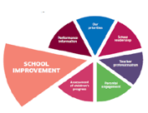  NIF Priority  Supporting and understanding of children’s social and emotional development. |  | EDLM PRIORITY  P,P & P  EDLM Priority  Presence, Participation and Progress | Care Inspectorate Quality Framework QIs  1.1 Nurturing Care and Support · 1.2 Children are Safe and Protected · 1.3 Play and Learning · 1.4 Family Engagement · 1.5 Effective Transitions | HGIOELC QI  …  2.1 Safeguarding and Child Protection2.2 Curriculum (Pedagogy and Play)  · 2.4 Personalised Support
Action |  | Outcomes and Measurement Including use of HGIOELC Challenge questions | Responsibility | Timescale | Progress
Supporting and understanding of children’s social and emotional development. |  | To seek support from other professionals and provide focussed training to support practice.  Ongoing supporting learners meetings with emphasis on all staff being confident and consistent in strategies identified.  To provide further training on safeguarding and child protection practice.  To streamline processes when identifying a need for support (TATC) | Michele Kay SEYP  Katie Elder EYCM | This box should be used to note progress throughout the session

For schools only
Further PEF Interventions (not included in SIP)

Identified Equity Gap …

NIF PRIORITY |  | EDLM PRIORITY  Presence |  | PEF (where applicable)  Intervention for equity & cost  See PEF plan |  | HGIOS QI  2.4
Identified Equity Gap | Action |  | Outcomes and Measurement Including use of HGIOS Challenge questions |  | Responsibility |  | Progress
Attendance  Audit current reasons for absence.  Collect feedback from students, parents, and teachers to understand and address attendance barriers.  Identify trends and patterns of absence for individuals, families and cohorts.  Identify other more hidden reasons impacting on individual cases.  Update policy | Target group with specific interventions:  - Ancrum outdoors  - DUSC School of Football  - COSD  - After school clubs (including meals)  - Development of nurture spaces/ new ESA structure  - Aberlour  - YARD  - Rock Solid  Ensure walking bus on two routes in the areas- plan for staffing this. |  | Monthly cohort and individual attendance tracking  Track the impact of the ARG process on improvement of attendance  Adapt our approaches when responding to absence by continually reflecting on the impact of the interventions in place to ensure the desired impact. |  | EDLM task group  D Millar SFDW  A McInally PEYSA  T Ross HT  C Narey Community Family Support Worker

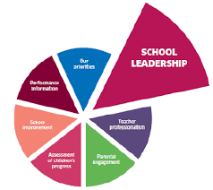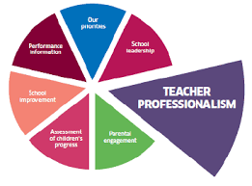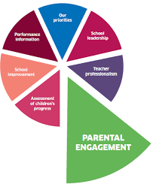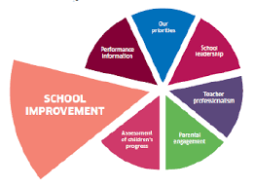

All NIF visuals

Summary of PEF Spend

Area of spend | Details | Budgeted allocated
Support staff | 1 PEYSA | 28,000
Supported study
Transport | Buses to residential & school trips | 5000
CLPL | Jane Mudd | 400
Resources | Enhanced Support Area | 10,000
Payments to other bodies | SFA, Ancrum | 25,000
Other (please specify) | Rock Solid, Horseriding, Aberlour  Residential Trip, The Yard, Climbing Wall | 10,000

